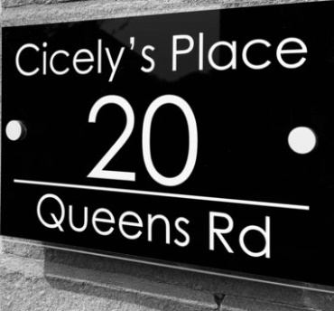

1 . Definitions: where mentioned below ' Guest' means the person making the holiday booking and all members of his or her party. 'The Owner ' means the owner of the accommodation let to the Guest. The Guest must be 18 years of age or over when the booking is made.

2 . All lettings are solely for the purpose of conferring on the Guest the right to occupy the accommodation for the purpose of the holiday.

3 . All holiday lettings will begin at 4.00pm on the day of arrival and end at 10.00am on the day of departure.

4 . The property and its related facilities must be left in a clean and tidy condition. All
breakages must be reported to the Owner and paid for. All guests are equally and
severally liable for any damages.

5 . The Owner shall not be liable in respect of claims that the Guest may have for death or any personal injury however caused or sustained by the Guest, unless it results from the Owner's act or omission, and the loss or damage to his/her belongings which are on the premises of the Owner.

6 . The Owner reserves the right to enter the accommodation at any time during the
period of the letting. Wherever possible, Guests will be advised of the need to enter
premises.

7 . The Owner reserves the right to refuse accommodation or to repossess the accommodation if they reasonably believe that any damage is likely to be caused by you or your party or can repossess the accommodation if damage has been caused.
These circumstances will be treated as a cancellation by the Guest.

8 . In the unlikely event that the accommodation already booked should subsequently become unavailable due to circumstances beyond the control of the Owner every effort will be made to find suitable alternative accommodation. Should this not be possible all monies paid by the Guest will be refunded immediately but the Owner shall not be liable in any circumstances to make any payment in excess of those monies.

9 . The deposit, 20% of the cost of the holiday, is payable within 48 hours of the booking being made and the balance will become payable at least six weeks prior to the date of commencement of the letting. Monies paid under the terms of this clause are not refunded by the Owner and will be forfeited if the Guest cannot take up the booking made for any reason whatsoever. However, the Owner recognises that in some cases of cancellation notwithstanding that there is no legal obligation to do so, the Owner will use its best endeavours to re-let the accommodation for the period of the booking and if successful the Owner will refund the monies paid to the Guest less £50.00 in respect of the additional expense in connection with the re-letting and less any difference between the original price and the re-let price. No refund will be given if the Guest cannot for whatever reason arrive at the property as booked. You are strongly advised to take out holiday cancellation insurance to cover all eventualities, including the weather.

10 . Where a booking is made within six weeks of taking up the let the full amount is
payable.

11 . The number and names of persons stated on the particulars supplied as being allowed to occupy and use the accommodation and facilities selected by the Guest is the total number. Sub-letting is not permitted, the names of all the guests who will be occupying the accommodation must be provided, on request, to the owners.

13 . Two dogs are permitted at no extra charge and must be stated on the particulars
supplied. Dogs are not allowed on the furniture or beds and must not be left alone in the property. You must remove as much dog hair as possible prior to your departure.

14. When an infant is included in the booking, bringing the total number of guests to 5, the infant must not be older than 24 months at the commencement of your stay.

